**Foresight.ai**

**“AI powered stock investment advisory”**

**(September 2022 - March 2023)**

Institute of Business Administration - BS Computer Science (Batch of 2023)

Project Supervisor: Dr. Tahir Syed

Team:

* Syed Hussain Imam - 19773
* Razi Moosa - 18663
* Ahmed Abdul Ghafoor - 19735
* Huzaifa Farooq - 19766

**Excecutive Summary**

Stock market analysis and prediction has been a very important area of study in the realm of finance. Current investors, primarily individual investors rely heavily on publicly available news sources and sentiment. Making sound investment decisions proves to be an extremely difficult task due the the amount of information needed to consistently beat the market. The current widely used practices for stock market prediction are:

* Historical price information
* Sentiment analysis of news and general public opinion
* Macro and Micro economic factors such as
  + Interest rates
  + Exchange rates
  + Industry specific information:
    - Growth rates
    - Consumer prices
    - Income statements
    - Dividend yields

Efficient market hypothesis states that all available information is accounted for in the current stock price, Hence it is impossible to predict future prices without any new information. This is a debated issue and stock markets around the world provide significant evidence that markets are not fully efficient.

To take advantage of this we will be creating a stock advisory platform that will take advantage of artificial intelligence techniques. We will take the technical analysis approach where we take into account psychological factors that affect future prices and trends. The crowd psychology of collective panic, fear, pessimism, confidence, excessive optimsim and greed.

Alot of popular techniques aim to quantity is factor namely:

* Moving Averages (MA)
* Auto Regressive Integrated Moving Average (ARIMA)
* Artificial Intelligence techniques

Over the course of this project we will be studying past researches of how accurately different approaches have attempted to predict stock price and their limitations. Alongside building the advisory plaftorm we will be reviewing these approaches.

The Advisory platform will be a publicly available web application in the beginning but will move to subscription model for individual and institutional investors in the future. The platform will provide precise stock information of all stocks in the KSE-100 regular index, the app will visualize the predictions of our model and provide advisement for investments to users. The users will be able to filter, select, and follow the stocks of their choice.

The level of individual investor engagement is very low in the Pakistan Stock Exchange (PSX) compared to other countries. This platform will also try to promote individuals to become more active in the PSX by providing important information and advisement that is difficult for new users to understand or find in currently available data portals.

**Project Plan**

* Project timeline (September 2022 - March 2023)
  + Dataset Review and Cleaning (October 2022)
  + Initial Model building (November - December 2022)
  + Deployment of Model (End of Semester 7)
  + Development of Web Application (January 2023 - February 2023)
  + Optimization of Model (January 2023 - February 2023)
    - Dev Team and AI team will work in parallel at this point
* Techonology and Resources
  + Dataset
    - [Open-source dataset](https://www.kaggle.com/datasets/borismarjanovic/price-volume-data-for-all-us-stocks-etfs?datasetId=4538) of Stocks and ETFs trading on NYSE, NASDAQ and NYSE MKT.
    - Dataset gathered from the KSE-100 for the past 5 years throught the publicly available data portal of [PSX](https://dps.psx.com.pk/historical)
  + Model Building Tech
    - Scikit
    - Matplotlib
    - Numpy
    - TensorFlow/Pytorch for DL models
    - Google Colab for model building and data processing
  + Web Development
    - Reactjs/Nextjs (Frontend)
    - Nodejs/Nestjs (Backend/Server Side)
    - MySql for main database Requirments
    - Mongodb for general document storage
    - AWS (Model and app deployments)
  + GPU and CPU intensive workloads
    - Google Colab (Free Version)

*All service deployments will be done over the cloud for 24/7 availability and scalability*

**Similar Products and limitations**

* **Stock brokerage firms**
  + Interactive Brokers
  + FsEdge
  + SCS Trade

These firms come with high advisement fees, human error and very low user exposure to stock investment.

* **Mutual Funds**
  + MCB
  + Meezan
  + UBL
  + HBL

Mutual funds promise sustained returns over long periods of times. People cannot readily take out their money as they are then subject to high fees and taxation. The return in comparatively very low if held in contrast to returns of other investors.

**Why do you need us?**

* The user is always in control, since they are managing their own investments
* High exposure to Market Data
* Ease of use
* Marginal fees for use and no fees for market gains (Unlike paid brokerage platforms)
* Artificial intelligence models helping to make sound investment decisions

**Future Work**

* We can extend our web app to a mobile app for increased ease of use. The access of mobile phones is far greater than desktops and laptops.
* Integration with PSX directly to provide real-time data, TREC license to act as a broker for our existing users.

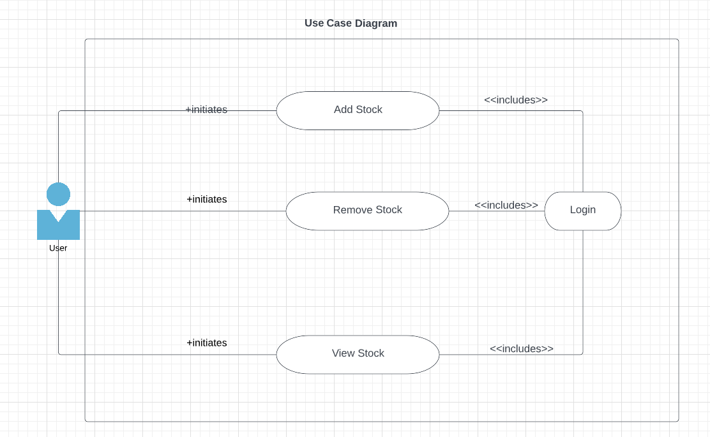

**References**

1. [**Marwala, Lufuno Ronald. "Forecasting the stock market index using artificial intelligence techniques." (2010).**](https://core.ac.uk/download/pdf/39667613.pdf)
2. [Predicting future stock price with historical data](https://www.kaggle.com/datasets/borismarjanovic/price-volume-data-for-all-us-stocks-etfs?datasetId=4538)
3. [C.H. Ellaji, P. Jayasri, C. Pradeepthi, G. Sreehitha, AI-based approaches for profitable investment and trading in stock market, Materials Today: Proceedings, 2021](https://www.sciencedirect.com/science/article/pii/S2214785321012700)
4. [AI based stock market investment hedge fund](https://numer.ai/fund)